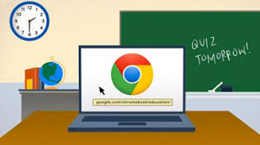
Chrome Book Rules:

- Wait for your ______________________________ or _____________________________ to be called.

- Handle your Chromebook with extreme ________________ and _________________________.

- Use ________________ hands to carry it while the screen is ____________________________________.

- Use it ____________________to conduct research , create projects, and complete classroom __________________________________.

- 5 Minute Rule:
  - You have five minutes to:
    - Report ______________________to the Chromebook

    - Report ______________________________
websites/pictures
  - If you do not report it you will be held responsible for it whether you did it or not. You will _________________________________.

- Be sure to ______________________________ your Chromebook each day and ___________________ it to the Chromebook cart.

- Place your Chromebook in the cart on its matching number with the power plug facing ____________________.

- DO NOT:
  - Leave it on the ________________ or stack it on top of books.

  - Do not lean on the computer screen or wiggle the screen_______________________.

  - Carry it or pass it around with the screen ______________________.

  - Slam on the keyboard or type with ______________ hands.

  - ____________________ or ___________________near the Chromebook.

  - Go to websites or conduct online searches that are ________________________to the assigned topic.
